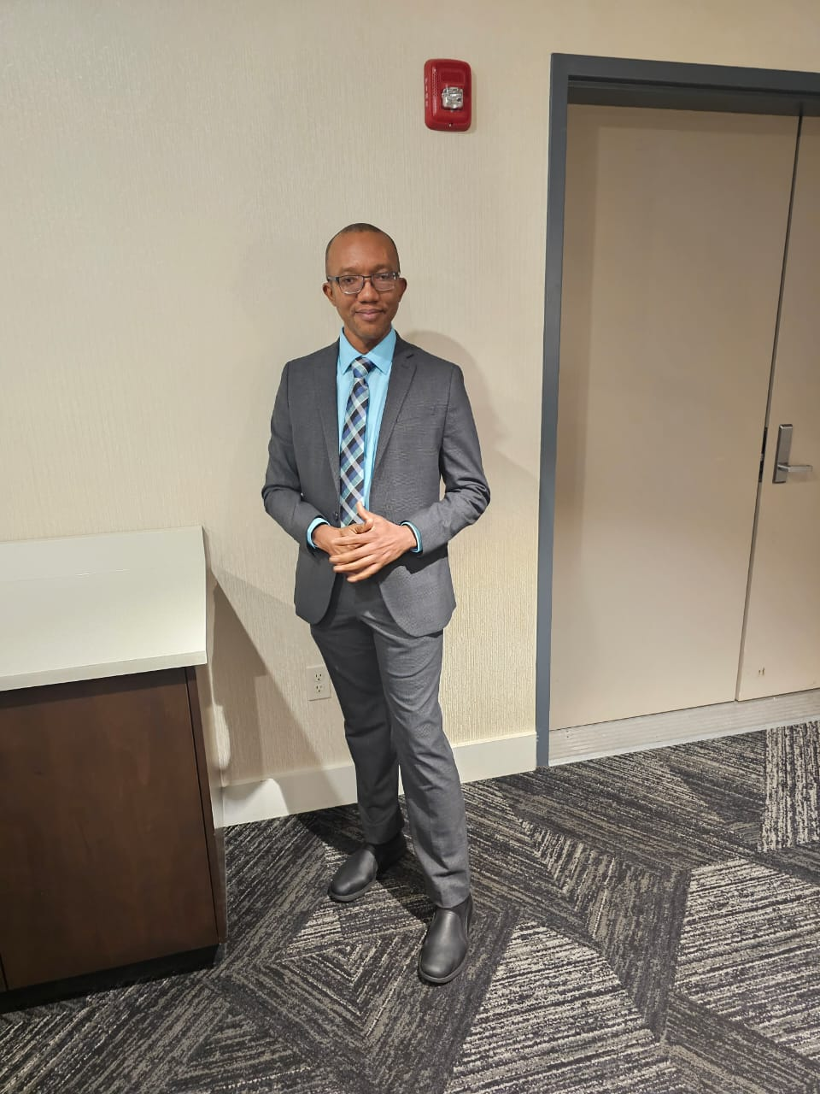
Shawn O’Neil Harrison
I am honored to be a member of the Academic Teaching Staff of Westside High School and I am delighted to have you as my students.
I am a graduate of the University of the West Indies, Mona, and Shortwood Teachers’ College both in Kingston, Jamaica. I am a holder of Master of Arts in English Language, a Batchelor of Arts in Spanish and Language Communication, a Diploma in Teaching with specialization in Spanish and Linguistics, and a Diploma in Spanish from the Venezuelan Institute for Culture and Cooperation (El Instituto de Venezolano para la Cultura y Cooperación).
I have an innate passion to see my students reach their full learning potential and excel in Spanish. I promise you that I will use the various pedagogical methods and best practices to help you to be successful in Spanish II.
Finally, I commit myself to helping you to be motivated daily and to develop the self-confidence and discipline to do your best.
Therefore, I urge you to be Wholehearted, Accountable, and Respectful at Westside High School.

I believe in you and your dreams!

